Project Report Template

1. **INTRODUCTION**
   1. Overview

* A startup is a newly formed business that is usually in the early stages of operations, typically characterized by a lack of established processes and means of generating revenue.
* ​A startup is an entrepreneurial venture that is designed to pursue a new and innovative concept or product, often with the goal of achieving rapid growth in a short amount of time.
* ​Startups are typically founded by individuals or small teams, with the intention of developing a successful business that can generate profit.
* ​While not all startups will be successful, those that do succeed can have significant rewards for their founders and investors alike
* A startup is a company that's in the initial stages of business. Founders normally finance their startups and may attempt to attract outside investment before they get off the ground. Funding sources include family and friends, venture capitalists, crowdfunding, and loans.
* A start up summary business plan includes the description of your products and services, the structure of your business, your target market, marketing strategy, funding requirements, financial projections, and licensing requirements, among others. It serves as a roadmap for your business.
* startup is a company that's in the initial stages of business. Founders normally finance their startups and may attempt to attract outside investment before they get off the ground. Funding sources include family and friends, venture capitalists, crowdfunding, and loans.
  1. **Purpose**
* Startups have also become more visible due to the rise of venture capital, which provides funding for earlystage companies.
* ​many successful startups have gone on to become publicly traded companies or have been acquired by large corporations for significant sums of money
* Overall, a startup is an entrepreneurial venture that is focused on rapidly developing and launching an innovative product or service.
* ​Startups are typically characterized by having limited resources and capital at their disposal, as well as limited employees.
* A startup analysis is essential to the success of any startup business. It allows entrepreneurs to identify the key areas that need improvement and make necessary changes early on. Doing a startup analysis also allows startups to track their progress and ensure that they are on track to achieve their goals.
* Startup analysis is purpose of essential because it allows them to decide the type of marketing strategy that will reach and resonate with the most people in their target demographic. They can then allocate their funds in such a way that their choices are supported.
* It allows entrepreneurs to identify the key areas that need improvement and make necessary changes early on.

1. **Problem Definition & Design Thinking**
   1. Empathy Map

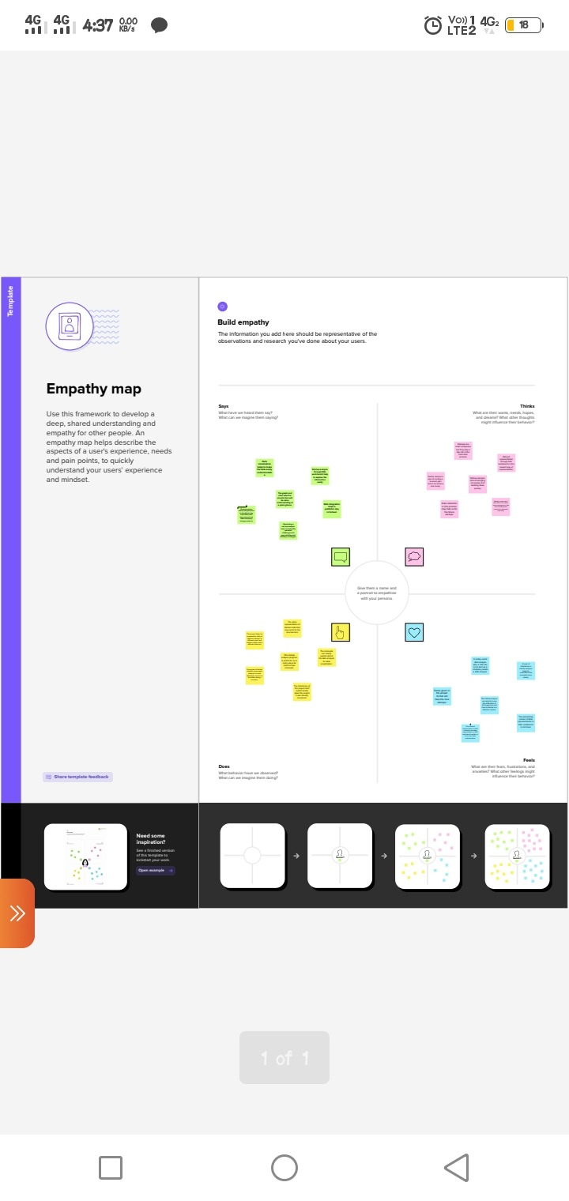

2.2 Ideation & Brainstorming Map

**3.RESULT**

**3.1** Data Model:

**3.1** Data Model:

**Object name Fields in the Object**

obj1

Field label Data type

obj2

Field label Data type

**3.2 Activity & Screenshot**

**4.** **Trailhead profile public URL**

**Team lead https://trailblazer.me/id/gomap2**

**Team Member 1 https://trailblazer.me/id/vjayasri2**

**Team Member 2 https://trailblazer.me/id/priyb37**

**Team Member 3 https://trailblazer.me/id/ssowmiya13**

**Team Member 4** [**https://trailblazer.me/id/gayad11**](https://trailblazer.me/id/gayad11)

**Team Member 5** [**https://trailblazer.me/id/subasubramani**](https://trailblazer.me/id/subasubramani)

**5 ADVANTAGES & DISADVANTAGE**

* HIGHER COST, TAXES AND REGULATIONS FOR STARTUPS:
* Startups deliver their products and services with a personal touch

**DISAVANTAGE**

* Most startups fail within their first year of operations, so the risk of failure is high**.**
* We watching vedio in phone more time consuming

**6 APPLICATIONS**

* Streaming services, E-commerce industries and cyber security these are the main areas the start idea can be applied
* This course will be useful for the beginners of startup business and this kind of datas or very useful in future for starting any business and mainly for entrepreneur

* Application of startup analysis

Recruitment.

Streaming services.

ecommerce industry.

Cybersecurity.

**7.CONCLUSION**

* successful startups do have the potential to create a significant positive impact on the world.
* A lean startup is a method used to found a new company or introduce a new product on behalf of an existing company.
* We have gained lot of information through this course and learn many things about my SQL table public and how to publish the datas visualisation in table we have learnt this kind of things it's very helpful and a start of analysis is a essential thing in our future

**8**. **FUTURE SCOPE**

* Students go to collage they participate in different platforms and try to make their own startup. They think in a different direction and try to become innovative
* and see an entrepreneur in themselves.
* a start-up contributes to economic development by increasing innovation and inducing competition.